**Task1**

**AuthenticationServlet**

/*

* Click nbfs://nbhost/SystemFileSystem/Templates/Licenses/license-default.txt to change this license

* Click nbfs://nbhost/SystemFileSystem/Templates/JSP_Servlet/Servlet.java to edit this template

*/

import jakarta.servlet.annotation.WebServlet;

import jakarta.servlet.http.HttpServlet;

import java.io.IOException;

import jakarta.servlet.ServletException;

import jakarta.servlet.annotation.WebServlet;

import jakarta.servlet.http.Cookie;

import jakarta.servlet.http.HttpServlet;

import jakarta.servlet.http.HttpServletRequest;

import jakarta.servlet.http.HttpServletResponse;

@WebServlet("/auth")

public class AuthenticationServlet extends HttpServlet {

private static final long serialVersionUID = 1L;

private final User sampleUser = new User("sampleuser", "password123");

protected void doPost(HttpServletRequest request, HttpServletResponse response)

throws ServletException, IOException {

String username = request.getParameter("username");

String password = request.getParameter("password");

if ("Haroon".equals(username) && "123".equals(password)) {

// Authentication successful

Cookie authCookie = new Cookie("userAuth", username);

response.addCookie(authCookie); response.getWriter().write("Authentication successful.");

} else {

response.getWriter().write("Authentication failed.");

}

}

}

**SecureServelet:**

/*

* Click nbfs://nbhost/SystemFileSystem/Templates/Licenses/license-default.txt to change this license

* Click nbfs://nbhost/SystemFileSystem/Templates/JSP_Servlet/Servlet.java to edit this template

*/

import java.io.IOException;

import java.io.PrintWriter;

import jakarta.servlet.ServletException;

import jakarta.servlet.http.HttpServlet;

import jakarta.servlet.http.HttpServletRequest;

import jakarta.servlet.http.HttpServletResponse;

/**

*

* @author test23

*/

public class SecureServelet extends HttpServlet {

protected void processRequest(HttpServletRequest request, HttpServletResponse response)

throws ServletException, IOException {

response.setContentType("text/html;charset=UTF-8");

try (PrintWriter out = response.getWriter()) {

out.println("<!DOCTYPE html>");

out.println("<html>");

out.println("<head>");

out.println("<title>Servlet SecureServelet</title>");

out.println("</head>");

out.println("<body>");

out.println("<h1>Servlet SecureServelet at " + request.getContextPath() + "</h1>");

out.println("</body>");

out.println("</html>");

}

}

// <editor-fold defaultstate="collapsed" desc="HttpServlet methods. Click on the + sign on the left to edit the code.">

/**

* Handles the HTTP <code>GET</code> method.

*

* @param request servlet request

* @param response servlet response

* @throws ServletException if a servlet-specific error occurs

* @throws IOException if an I/O error occurs

*/

@Override

protected void doGet(HttpServletRequest request, HttpServletResponse response)

throws ServletException, IOException {

processRequest(request, response);

}

/**

* Handles the HTTP <code>POST</code> method.

*

* @param request servlet request

* @param response servlet response

* @throws ServletException if a servlet-specific error occurs

* @throws IOException if an I/O error occurs

*/

@Override

protected void doPost(HttpServletRequest request, HttpServletResponse response)

throws ServletException, IOException {

processRequest(request, response);

}

/**

* Returns a short description of the servlet.

*

* @return a String containing servlet description

*/

@Override

public String getServletInfo() {

return "Short description";

}// </editor-fold>

}

**User Class:**

/*

* Click nbfs://nbhost/SystemFileSystem/Templates/Licenses/license-default.txt to change this license

* Click nbfs://nbhost/SystemFileSystem/Templates/Classes/Class.java to edit this template

*/

/**

*

* @author test23

*/

public class User {

private String username;

private String password;

public User(String username, String password) {

this.username = username;

this.password = password;

}

public String getUsername() {

return username;

}

public String getPassword() {

return password;

}

}

**Task2:**

/*

* Click nbfs://nbhost/SystemFileSystem/Templates/Licenses/license-default.txt to change this license

* Click nbfs://nbhost/SystemFileSystem/Templates/JSP_Servlet/Servlet.java to edit this template

*/

import java.io.IOException;

import jakarta.servlet.ServletException;

import jakarta.servlet.annotation.WebServlet;

import jakarta.servlet.http.Cookie;

import jakarta.servlet.http.HttpServlet;

import jakarta.servlet.http.HttpServletRequest;

import jakarta.servlet.http.HttpServletResponse;

@WebServlet("/readCookie")

public class CookieReaderServlet extends HttpServlet {

private static final long serialVersionUID = 1L;

protected void doGet(HttpServletRequest request, HttpServletResponse response)

throws ServletException, IOException {

String cookieName = "myCookie";

Cookie[] cookies = request.getCookies();

if (cookies != null) {

for (Cookie cookie : cookies) {

if (cookieName.equals(cookie.getName())) {

String cookieValue = cookie.getValue();

response.getWriter().write("Cookie Value: " + cookieValue);

return;

}

}

}

// If the cookie is not present, display a message

response.getWriter().write("Cookie not set.");

}

}

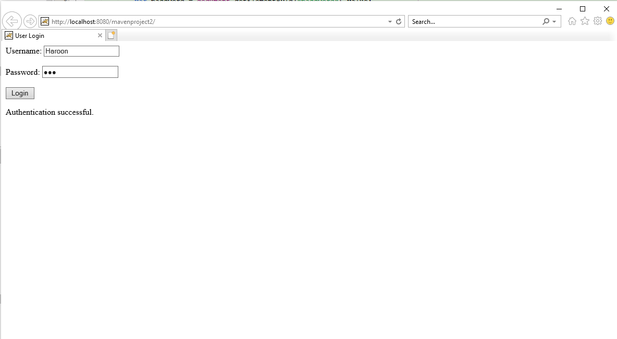

**Task3:**

/*

* Click nbfs://nbhost/SystemFileSystem/Templates/Licenses/license-default.txt to change this license

* Click nbfs://nbhost/SystemFileSystem/Templates/JSP_Servlet/Servlet.java to edit this template

*/

import jakarta.servlet.annotation.WebServlet;

import jakarta.servlet.http.HttpServlet;

import java.io.IOException;

import jakarta.servlet.ServletException;

import jakarta.servlet.annotation.WebServlet;

import jakarta.servlet.http.Cookie;

import jakarta.servlet.http.HttpServlet;

import jakarta.servlet.http.HttpServletRequest;

import jakarta.servlet.http.HttpServletResponse;

@WebServlet("/auth")

public class RememberMeServelet extends HttpServlet {

private static final long serialVersionUID = 1L;

private final User sampleUser = new User("sampleuser", "password123");

protected void doPost(HttpServletRequest request, HttpServletResponse response)

throws ServletException, IOException {

String username = request.getParameter("username");

String password = request.getParameter("password");

boolean rememberMe = request.getParameter("rememberMe") != null;

if (authenticateUser(username, password)) {

if (rememberMe) {

Cookie usernameCookie = new Cookie("rememberedUsername", username);

Cookie passwordCookie = new Cookie("rememberedPassword", password);

usernameCookie.setMaxAge(60 * 60 * 24 * 30); // Set the cookie to expire in 30 days

passwordCookie.setMaxAge(60 * 60 * 24 * 30);

response.addCookie(usernameCookie);

response.addCookie(passwordCookie);

}

response.getWriter().write("Authentication successful.");

} else {

response.getWriter().write("Authentication failed.");

}

}

private boolean authenticateUser(String username, String password) {

return "Haroon".equals(username) && "123".equals(password);

}

}

**Task4:**

**Product class:**

public class Product {

private String productId;

private String name;

private double price;

public Product(String productId, String name, double price) {

this.productId = productId;

this.name = name;

this.price = price;

}

}

**ShoppingCartServlet**:

@WebServlet("/addToCart")

public class ShoppingCartServlet extends HttpServlet {

protected void doGet(HttpServletRequest request, HttpServletResponse response)

throws ServletException, IOException {

// Retrieve cart contents from cookies and display them

}

protected void doPost(HttpServletRequest request, HttpServletResponse response)

throws ServletException, IOException {

String productId = request.getParameter("productId");

String productName = request.getParameter("productName");

double productPrice = Double.parseDouble(request.getParameter("productPrice"));

Cookie[] cookies = request.getCookies();

List<Product> cart = new ArrayList<>();

if (cookies != null) {

for (Cookie cookie : cookies) {

if (cookie.getName().equals("cartItem")) {

// Parse the cart item from the cookie value and add it to the cart list

String[] parts = cookie.getValue().split(":");

String productId = parts[0];

String productName = parts[1];

double productPrice = Double.parseDouble(parts[2]);

Product product = new Product(productId, productName, productPrice);

cart.add(product);

}

}

}

cart.add(new Product(productId, productName, productPrice)); // Add the new item to the cart

// Update the cart cookies

Cookie cartCookie = new Cookie("cartItem", ""); // Initialize a new cart cookie

for (Product product : cart) {

cartCookie.setValue(product.getProductId() + ":" + product.getName() + ":" + product.getPrice());

response.addCookie(cartCookie);

}

}

**Task5:**

**DataReceiverServlet:**

import java.io.IOException;

import javax.servlet.ServletException;

import javax.servlet.annotation.WebServlet;

import javax.servlet.http.HttpServlet;

import javax.servlet.http.HttpServletRequest;

import javax.servlet.http.HttpServletResponse;

@WebServlet("/dataReceiver")

public class DataReceiverServlet extends HttpServlet {

protected void doPost(HttpServletRequest request, HttpServletResponse response)

throws ServletException, IOException {

String username = request.getParameter("username");

String email = request.getParameter("email");

String message = request.getParameter("message");

response.setContentType("text/html");

response.getWriter().println("<html><head><title>Submitted Data</title></head><body>");

response.getWriter().println("<h1>Submitted Data</h1>");

response.getWriter().println("<p>Username: " + username + "</p>");

response.getWriter().println("<p>Email: " + email + "</p>");

response.getWriter().println("<p>Message: " + message + "</p>");

response.getWriter().println("</body></html>");

}

}

**Task6:**

**HttpStatusDemoServlet:**

import java.io.IOException;

import javax.servlet.ServletException;

import javax.servlet.annotation.WebServlet;

import javax.servlet.http.HttpServlet;

import javax.servlet.http.HttpServletRequest;

import javax.servlet.http.HttpServletResponse;

@WebServlet("/httpStatusDemo")

public class HttpStatusDemoServlet extends HttpServlet {

protected void doGet(HttpServletRequest request, HttpServletResponse response)

throws ServletException, IOException {

String statusParam = request.getParameter("status");

if (statusParam == null) {

response.getWriter().println("Please provide a 'status' parameter (e.g., ?status=404) to see different HTTP status codes.");

} else {

try {

int statusCode = Integer.parseInt(statusParam);

response.setStatus(statusCode);

switch (statusCode) {

case 200:

response.getWriter().println("200 OK - Request was successful.");

break;

case 201:

response.getWriter().println("201 Created - Request has been fulfilled, and a new resource has been created.");

break;

case 204:

response.getWriter().println("204 No Content - Request was successful, but there is no response body.");

break;

case 400:

response.getWriter().println("400 Bad Request - The server could not understand the request.");

break;

case 401:

response.getWriter().println("401 Unauthorized - Authentication is required and has failed.");

break;

case 403:

response.getWriter().println("403 Forbidden - Authentication succeeded, but the authenticated user does not have access.");

break;

case 404:

response.getWriter().println("404 Not Found - The requested resource does not exist.");

break;

case 500:

response.getWriter().println("500 Internal Server Error - A generic error message.");

break;

default:

response.getWriter().println("Unknown status code: " + statusCode);

break;

}

} catch (NumberFormatException e) {

response.setStatus(HttpServletResponse.SC_BAD_REQUEST);

response.getWriter().println("Invalid 'status' parameter. Please provide a valid HTTP status code.");

}

}

}

}

**Task7:**

**SessionDemoServlet:**

import java.io.IOException;

import javax.servlet.ServletException;

import javax.servlet.annotation.WebServlet;

import javax.servlet.http.HttpServlet;

import javax.servlet.http.HttpServletRequest;

import javax.servlet.http.HttpServletResponse;

import javax.servlet.http.HttpSession;

@WebServlet("/sessionDemo")

public class SessionDemoServlet extends HttpServlet {

protected void doGet(HttpServletRequest request, HttpServletResponse response)

throws ServletException, IOException {

HttpSession session = request.getSession(); // Get or create a session

// Store and retrieve session attributes

String attributeName = "username";

String attributeValue = "JohnDoe";

if (session.getAttribute(attributeName) == null) {

// Store the attribute in the session if not already set

session.setAttribute(attributeName, attributeValue);

}

// Retrieve the attribute from the session

String storedUsername = (String) session.getAttribute(attributeName);

// Display the user's session ID

String sessionId = session.getId();

response.setContentType("text/html");

response.getWriter().println("<html><head><title>Session Demo</title></head><body>");

response.getWriter().println("<h1>Session Demo</h1>");

response.getWriter().println("Session ID: " + sessionId + "<br>");

response.getWriter().println("Stored Username: " + storedUsername + "<br>");

response.getWriter().println("</body></html>");

}

}

**Task8:**

**Step1Servlet:**

import java.io.IOException;

import javax.servlet.ServletException;

import javax.servlet.annotation.WebServlet;

import javax.servlet.http.HttpServlet;

import javax.servlet.http.HttpServletRequest;

import javax.servlet.http.HttpServletResponse;

@WebServlet("/step1")

public class Step1Servlet extends HttpServlet {

protected void doGet(HttpServletRequest request, HttpServletResponse response)

throws ServletException, IOException {

request.getRequestDispatcher("/step1.html").forward(request, response);

}

protected void doPost(HttpServletRequest request, HttpServletResponse response)

throws ServletException, IOException {

// Process data from Step 1

String data1 = request.getParameter("data1");

request.getSession().setAttribute("data1", data1);

// Forward to Step 2

request.getRequestDispatcher("/step2").forward(request, response);

}

}

**Step2Servlet:**

import java.io.IOException;

import javax.servlet.ServletException;

import javax.servlet.annotation.WebServlet;

import javax.servlet.http.HttpServlet;

import javax.servlet.http.HttpServletRequest;

import javax.servlet.http.HttpServletResponse;

@WebServlet("/step2")

public class Step2Servlet extends HttpServlet {

protected void doGet(HttpServletRequest request, HttpServletResponse response)

throws ServletException, IOException {

request.getRequestDispatcher("/step2.html").forward(request, response);

}

protected void doPost(HttpServletRequest request, HttpServletResponse response)

throws ServletException, IOException {

// Process data from Step 2

String data2 = request.getParameter("data2");

request.getSession().setAttribute("data2", data2);

// Forward to Step 3

request.getRequestDispatcher("/step3").forward(request, response);

}

}

**Step3Servlet**:

import java.io.IOException;

import javax.servlet.ServletException;

import javax.servlet.annotation.WebServlet;

import javax.servlet.http.HttpServlet;

import javax.servlet.http.HttpServletRequest;

import javax.servlet.http.HttpServletResponse;

@WebServlet("/step3")

public class Step3Servlet extends HttpServlet {

protected void doGet(HttpServletRequest request, HttpServletResponse response)

throws ServletException, IOException {

request.getRequestDispatcher("/step3.html").forward(request, response);

}

protected void doPost(HttpServletRequest request, HttpServletResponse response)

throws ServletException, IOException {

// Process data from Step 3

String data3 = request.getParameter("data3");

request.getSession().setAttribute("data3", data3);

// Redirect to the completion page

response.sendRedirect("completion.html");

}

}